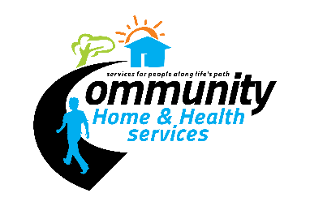
Meeting Date 01/20/2023
The following has been taken into consideration for this strategic plan. They include strengths, weaknesses, threats, and opportunities for Community Home and Health Services (CHHS).
- Expectations of Persons Served
  - To feel safe, feel welcome to do as they please in their home, have reliable staff, and companionship.
- Expectations of Stakeholders
  - Give clients proper care, timely and effective communication, professionalism, good attitudes, following through, and proper documentation.
- Competitive Environment
  - A lot of local competition, takes a special individual to want to do the work we do, CAN competition.
- Financial Opportunities
  - Filling available beds in WP and PHG, getting WP fully running again, hiring a driver for NEMT services, selling unused vans, and taking on more HCS clients.
- Financial Threats
  - Empty beds, losing clients due to ineffective care, lack of staffing, labor market, competition from local agencies.
- CHHS’s capabilities
  - CHHS locations are a community together, great teamwork, helpful staff, good communication, and dedication to the people we serve.
- Social Determinants of Health (conditions in which people are born, grow, live, work and age, area demographics) (transportation, housing, food access, healthcare access, social support, recreation, availability of community resources, job opportunities)
  - Limited transportation, rural living, child care, and competitive wages in the area contribute to limited staffing.
- Organization’s relationships with external stakeholders
  - Overall, CHHS has productive relationships, but communication can vary depending person to person. An issue CHHS has experienced is poor communication from certain stakeholders.
- Regulatory Environment
  - There continues to be regulations put in place that complicate service provision. EVV sets to create a ‘cookie cutter’ viewpoint for service provision, despite that each individual is unique.
- Legislative Environment
  - It understands there is a need to increase wages in order to retain healthcare workers in our field.
- Technology
  - Efficient operations - Printer/fax supplier is slow to respond, slow internet due to rural living, clocking-in/out difficult due to busy tone through ADP
- Information from Performance Analysis
  - Please see QI Work Plan 2022
- CHHS’s Financial Position (current, projected)
  - CHHS recently renegotiated its contracts that allowed Residential DCW wages to be increased to $15 an hour, HCS DCW wages to be increased to $14 an hour, and supervisor wages to be increased to $17 an hour. While the administrative fund has be reduced due to the HCS department’s reduced size and the closing of a home, it is hopeful that things will change due to changes in the labor market. “We are in a good state. The only thing that limits us is lack of employees. But the projection is positive.” -Jory Harland.
- General room for improvement: To ensure CHHS has positive representation in the community, increase our Indeed score, and increase communication with HCS providers.
Goals
- Increase staffing by 20%
- CHHS will spend $10,000 towards employee incentives and retainment.

Priorities
- Building up the HCS department
- Filling all available Residential department beds
- Attending community gatherings to show representation in the area.

